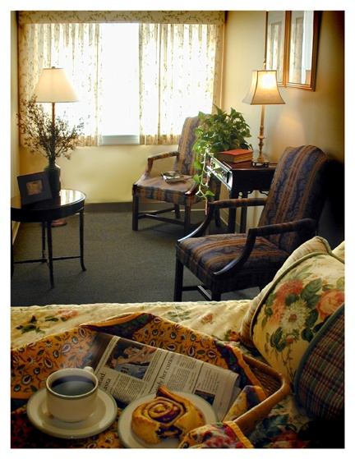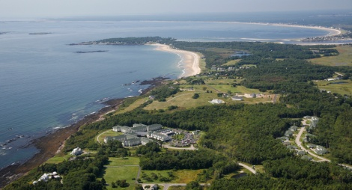
Health Center Activities May 2016
SUNDAY | MONDAY | TUESDAY | WEDNESDAY | THURSDAY | FRIDAY | SATURDAY
1  10:00AM  Sunday Catholic  Church Service  2:00PM  Card Game  3:30PM  Jazz Music with Ocean Sol | 2  10:00AM  HC Book Club  11:00AM  Exercise  3:30PM  Harp Concert:  “Judy Saiki” | 3  10:00AM  A Service of  Hymns & Prayers  11:00AM  Toning Exercise  2:00PM  Bingo  3:30PM  “Have You Ever?”  Social Hour | 4  9:30AM  Morning Prayer  10:15AM  Chair Massage  With Sue  1:00PM  Bus Outing:  Sunflower Farm Creamery  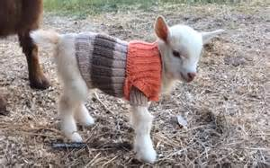 | 5  10:00AM  Ascension Day Mass  10:45AM  Sit & Fit  2:00PM  On the Road with Gabby & Paula  4:00PM (IL)  Cinco De Mayo Celebration | 6  10:00AM  Current events  2:00PM (AL)  Crossword Puzzle  3:30PM  Country Music with Glen Bryant | 7  10:00AM  Current Events  10:30AM  Bingo  2:00PM  Individual Visits  3:30PM (AL)  UNO Card Game
8  10:00AM  Sunday Catholic  Church Service  10:30AM (AL)  Violin Music with Andy Happel  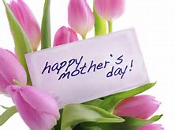 | 9  10:00AM  HC Book Club  11:00AM  Exercise  3:30PM  Folk Music with Sharon Wright | 10  10:00AM  A Service of  Hymns & Prayers  11:00AM  Toning Exercise  2:00PM  Bingo  3:30PM  Afternoon Card Game | 11  10:00AM  Current Events  1:00PM  Bus outing:  Bowdoin College  Art Museum  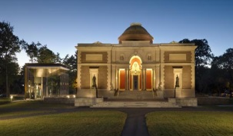 | 12  10:00AM  Spring Olympic  2:00PM  On the Road with Gabby & Paula  3:30PM  Zumba | 13  9:30AM  Daily Horoscope  10:00AM  Art Class with Heidi  2:00PM (AL)  Crossword Puzzle  3:30PM  Humor Group | 14  10:00AM  Bingo  2:00PM  Individual Visits  3:30PM  Piano Music with David Stone
15  10:00AM  Sunday Catholic  Church Service  10:30AM  City Theater:  Murder at the Howard Johnson  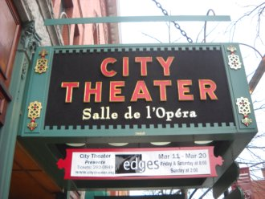  3:30PM  St. Albans  Church service | 16  10:00AM  HC Book Club  11:00AM  Exercise  3:30PM  On the Road with Gabby & Paula | 17  10:00AM  A Service of  Hymns & Prayers  11:00AM  Exercise  2:00PM  Bingo  3:00PM  Outdoor Strolls | 18  9:30AM  Morning Prayer  10:15AM  Piper Ukulele Group  1:00PM  Bus Outing:  Countryside Tour  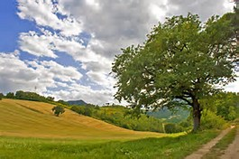 | 19  10:00AM  Current Events & Morning Trivia  10:45PM  Sit & Fit  2:30PM  Piper Shores  Chef Cook Off | 20  10:00AM  Bingo  2:00PM  Outdoor Strolls  3:30PM  Guitar music with Chris Heard | 21  10:00AM  Bingo  2:00PM  Individual Visits  3:00PM  Movie Presentation:  Shirley Temple  “Curley Top”
22  10:00AM  Sunday Catholic  Church Service  2:00PM(AL)  Card Game  3:30PM  Movie Presentation:  The Parent Trap | 23  10:00AM  Art Class with Heidi  2:00PM  Individual Visits  3:30PM  Root Beer Floats | 24  10:00AM  A Service of Hymns & Prayers  11:00AM  Exercise  2:00PM  Bingo  3:30PM  Guitar Music with Ben KilCollins | 25  10:15AM  Piper Ukulele Group  1:00PM  Bus outing:  Old Orchard Beach  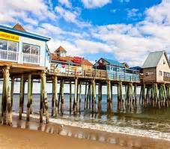 | 26  9:30AM-10:30AM  Flower Arranging  (HC- 2nd Floor)  ALREADY DISCUSSED- NOT MOVING  10:45AM  Sit & Fit  2:00PM (AL)  Humor Group  3:30PM  Zumba | 27  10:00AM  Current Events  10:30AM-11:30AM  Bingo  (HC- 2nd Floor)  CAN MOVE  2:00PM  Individual Visits  3:30PM-4:30PM  Sing- A- Long with Flash Allen  (HC- 2nd Floor)  CANNOT MOVE | 28  10:00AM  Bingo  2:00PM  Individual Visits  3:30PM  Piano Concert:  Michael Bealing
29  10:00AM  Sunday Catholic  Church Service  2:00PM (AL)  Card Game  3:30PM  Jazz Piano Music with Bess | 30  10:00AM  Current Events  10:30AM  Jazz music with  Pete, Per & Idgy | 31  10:00AM-10:30AM  A Service of hymns and Prayers  (HC- 2nd Floor)  CAN MOVE BUT WOULD RATHER NOT  11:00AM  Exercise  2:00PM-3:00PM  Bingo  (HC_ 2nd Floor)  CAN MOVE  3:30PM  Individual Visits |  |  | ABBREVIATION LEGEND  HC =  Health Center  AL =  Assisted Living  IL =  Independent Living | All events listed on this calendar take place in the Health Center Activity Room, unless otherwise specified. Please  See the Abbreviation Legend for a list of alternate locations.

