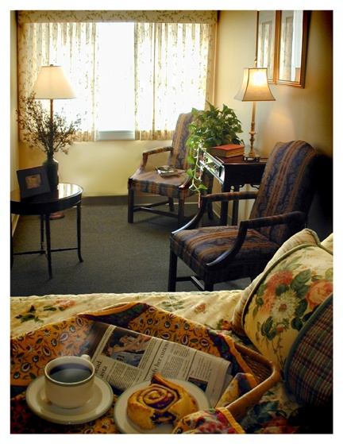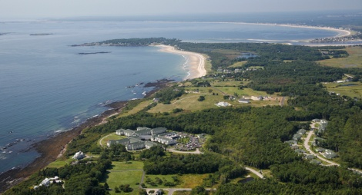
Assisted Living Activities May 2016
SUNDAY | MONDAY | TUESDAY | WEDNESDAY | THURSDAY | FRIDAY | SATURDAY
1  10:00AM  Sunday Catholic  Church Service  2:00PM  Card Game  3:30PM  Jazz Music with Ocean Sol | 2  11:30AM  Exercise  1:30PM  Knitting Group  2:00PM  AL Book Club  3:30PM  Harp Concert:  “Judy Saiki” | 3  10:00AM (HC)  A Service of  Hymns & Prayers  11:30AM  Sit & Fit  2:00PM  Afternoon Social  3:30PM  Art Class | 4  9:30AM (HC)  Morning Prayer  1:00PM  Bus Outing:  Sunflower Farm Creamery  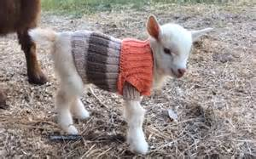 | 5  10:00AM (HC)  Ascension Day Mass  11:30AM  Exercise  2:00PM (HC)  On the Road with Gabby & Paula  4:00PM (IL)  Cinco De Mayo  Celebration | 6  10:00AM  Current events  2:00PM  Crossword Puzzle  3:30PM  Country Music with Glen Bryant | 7  10:00AM (HC)  Current Events  10:30AM (HC)  Bingo  2:00PM  Individual Visits  3:30PM  UNO Card Game
8  10:00AM  Sunday Catholic  Church Service  10:30AM (AL)  Violin Music with Andy Happel  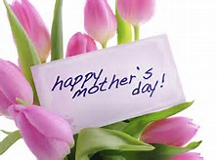 | 9  11:30AM  Exercise  1:30PM  Knitting Group  2:00PM  AL Book Club  3:30PM  Folk Music with Sharon Wright | 10  10:00AM (HC)  A Service of  Hymns & Prayers  11:30AM  Sit & Fit  2:00PM  Afternoon Social  3:30PM  Art Class | 11  10:00AM  Current Events  1:00PM  Bus outing:  Bowdoin College  Art Museum  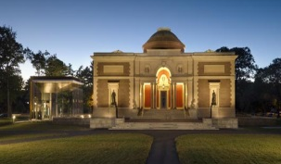 | 12  10:00AM (HC)  Spring Olympics  10:45AM  Sit and Fit  2:00PM  On the Road with Gabby & Paula  4:00PM  Zumba | 13  9:30AM  Daily Horoscope  10:00AM (HC)  Art Class with Heidi  2:00PM  Crossword Puzzle  3:30PM  Humor Group | 14  10:00AM  Bingo  2:00PM  Individual Visits  3:30PM  Piano Music with David Stone
15  10:00AM  Sunday Catholic  Church Service  10:30AM  City Theater:  Murder at the Howard Johnson  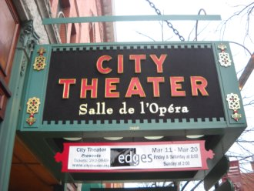  3:30PM  St. Albans  Church service | 16  11:30AM  Exercise  1:30PM  Knitting Group  2:00PM  AL Book Club  3:30PM (HC)  On the Road with Gabby & Paula | 17  10:00AM (HC)  A Service of  Hymns & Prayers  11:30AM  Sit & Fit  2:00PM  Afternoon Social  3:30PM  Art Class | 18  9:30AM (HC)  Morning Prayer  1:00PM  Bus Outing:  Countryside Tour  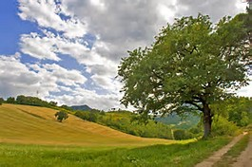 | 19  10:00AM  Current Events & Morning Trivia  11:30AM  Exercise  2:30PM  Piper Shores  Chef Cook Off | 20  10:00AM  Bingo  2:00PM  Individual Visits  3:30PM  Guitar music with Chris Heard | 21  10:00AM  Bingo  2:00PM  Individual Visits  3:00PM  Movie Presentation:  Roman Holiday  Gregory Peck & Audrey Hepburn
22  10:00AM  Sunday Catholic  Church Service  11:30AM  2:00PM  Card Game  3:30PM  Movie Presentation:  Shirley Temple  “Curley Top” | 23  10:00AM  Art Class with Heidi  2:00PM  Individual Visits  3:30PM  Root Beer Floats | 24  10:00AM (HC)  A Service of Hymns & Prayers  11:30AM  Sit & Fit  2:00PM  Afternoon Social  3:30PM (HC)  Guitar Music with Ben KilCollins | 25  1:00PM  Bus outing:  Old Orchard Beach  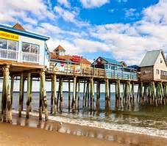 | 26  11:30AM  Exercise  2:00PM (HC)  Humor Group  4:00PM  Zumba | 27  10:00AM  Current Events  10:30AM  Bingo  2:00PM  Individual Visits  3:30PM  Sing- A- Long with Flash Allen | 28  10:00AM (HC)  Bingo  2:00PM  Individual Visits  3:30PM (HC)  Piano Music with  Michael Bealing
29  10:00AM (HC)  Sunday Catholic  Church Service  2:00PM  Card Game  3:30PM (HC)  Jazz Piano Music with Bess | 30  10:00AM  Current Events  10:30AM  Jazz music with  Pete, Per & Idgy | 31  10:00AM (HC)  A Service of hymns and Prayers  11:30AM  Sit & Fit  2:00PM  Afternoon Social  3:30PM  Art Class |  |  | ABBREVIATION LEGEND  HC =  Health Center  AL =  Assisted Living  IL =  Independent Living | All events listed on this calendar take place in the Health Center Activity Room, unless otherwise specified. Please  See the Abbreviation Legend for a list of alternate locations.

